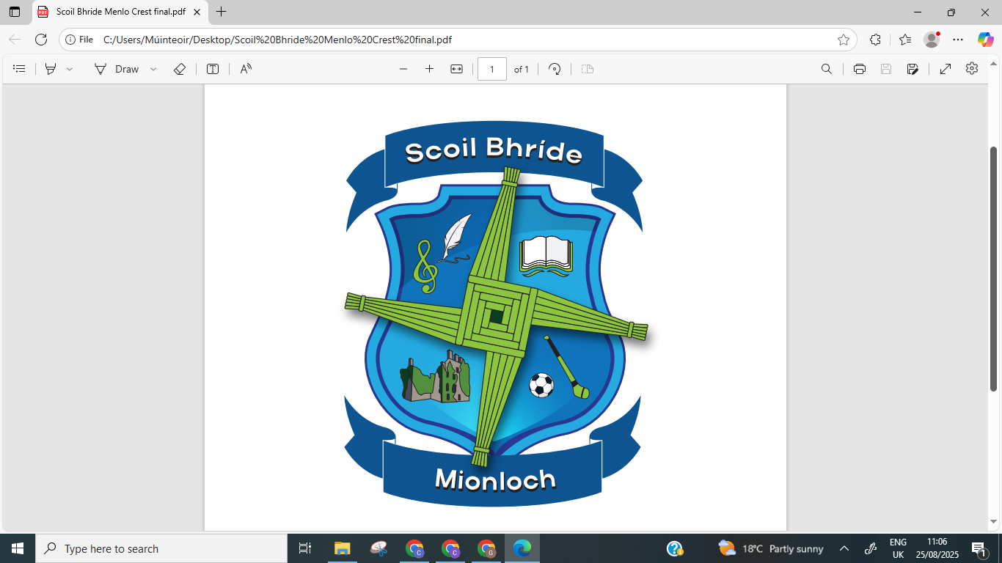

Bí Cineálta Policy to Prevent and Address Bullying Behaviour

Scoil Bhírde Mionloch

The Board of Management of Scoil Bhríde has adopted the following policy to prevent and address bullying behaviour on the _________________.

This policy fully complies with the requirements of Bí Cineálta: Procedures to Prevent and Address Bullying Behaviour for Primary and Post-Primary Schools 2024.

The board of management acknowledges that bullying behaviour interferes with the rights of the child as set out in the United Nations Convention on the Rights of the Child. We all, as a school community, have a responsibility to work together to prevent and address bullying behaviour and to deal with the negative impact of bullying behaviour.

We are committed to ensuring that all students who attend our school are kept safe from harm and that the wellbeing of our students is at the forefront of everything that we do. We recognise the negative impact that bullying behaviour can have on the lives of our students and we are fully committed to preventing and addressing bullying behaviour.

We confirm that we will, in accordance with our obligations under equality legislation, take all such steps that are reasonably practicable to prevent the harassment of students or staff on any of the nine grounds specified: gender, civil status, family status, sexual orientation, religion, age, disability, race and membership of the Traveller community.

We confirm that we will take all such steps that are reasonably practicable to prevent the bullying or harassment of our students in whatever form and however motivated.

Catholic schools have a distinctive understanding of the human person, recognising that every person is created in God's image and likeness and has inherent dignity as a child of God. This is the basis for ensuring that each person in our school is treated with respect and care, in accordance with the Catholic Schedule.

As a Catholic school, we are committed to respecting the dignity of every individual. No human person is to be devalued, and all have an indispensable part to play in the school community, regardless of difference.

Definition of bullying

Bullying is defined in Cineáltas: Action Plan on Bullying and Bí Cineálta: Procedures to Prevent and Address Bullying Behaviour for Primary and Post-Primary Schools as targeted behaviour, online or offline that causes harm. The harm caused can be physical, social and/or emotional in nature. Bullying behaviour is repeated over time and involves an imbalance of power in relationships between two people or groups of people in society. The detailed definition is provided in Chapter 2 of the Bí Cineálta procedures. Each school is required to develop and implement a Bí Cineálta policy that sets out how the school community prevents and addresses bullying behaviour. Strategies to deal with inappropriate behaviour that is not bullying behaviour are provided for within the school’s Code of Behaviour.

Siniú:__________________ Dáta:_______________
Cathaoirleach

Siniú:__________________ Dáta:_______________
Príomhoide

